**WEEK 5**

**Module 8 - Microservices with Spring Boot 3 and Spring Cloud**

**2.Microservices with API gateway**

**Creating Microservices for account and loan**

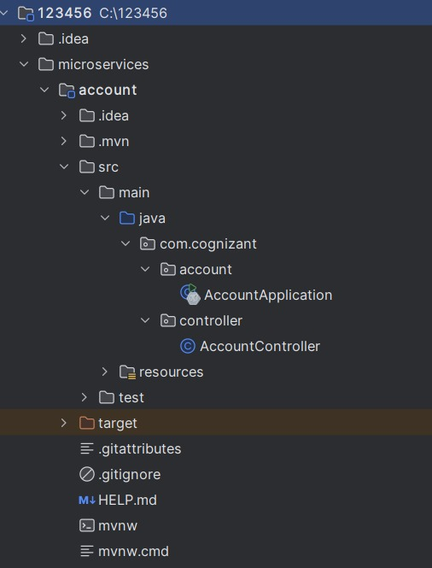**File Structure:**

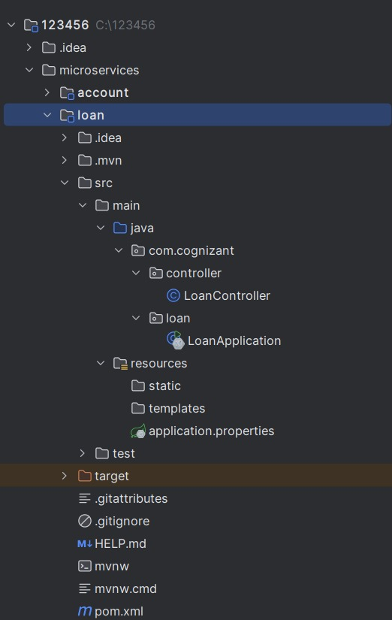

**CODE:**

**Pom.xml**

<?xml version="1.0" encoding="UTF-8"?>

<project xmlns="http://maven.apache.org/POM/4.0.0" xmlns:xsi="http://www.w3.org/2001/XMLSchema-instance"

xsi:schemaLocation="http://maven.apache.org/POM/4.0.0 https://maven.apache.org/xsd/maven-4.0.0.xsd">

<modelVersion>4.0.0</modelVersion>

<parent>

<groupId>org.springframework.boot</groupId>

<artifactId>spring-boot-starter-parent</artifactId>

<version>3.5.3</version>

<relativePath/> <!-- lookup parent from repository -->

</parent>

<groupId>com.example</groupId>

<artifactId>loan</artifactId>

<version>0.0.1-SNAPSHOT</version>

<name>loan</name>

<description>Demo project for Spring Boot</description>

<url/>

<licenses>

<license/>

</licenses>

<developers>

<developer/>

</developers>

<scm>

<connection/>

<developerConnection/>

<tag/>

<url/>

</scm>

<properties>

<java.version>17</java.version>

</properties>

<dependencies>

<dependency>

<groupId>org.springframework.boot</groupId>

<artifactId>spring-boot-starter-web</artifactId>

</dependency>

<dependency>

<groupId>org.springframework.boot</groupId>

<artifactId>spring-boot-devtools</artifactId>

<scope>runtime</scope>

<optional>true</optional>

</dependency>

<dependency>

<groupId>org.springframework.boot</groupId>

<artifactId>spring-boot-starter-test</artifactId>

<scope>test</scope>

</dependency>

</dependencies>

<build>

<plugins>

<plugin>

<groupId>org.springframework.boot</groupId>

<artifactId>spring-boot-maven-plugin</artifactId>

</plugin>

</plugins>

</build>

</project>

**C:\123456\microservices\account**

**src\main\java\com\cognizant\account\AccountApplication.java**

package com.cognizant.account;

import org.springframework.boot.SpringApplication;

import org.springframework.boot.autoconfigure.SpringBootApplication;

@SpringBootApplication

public class AccountApplication {

public static void main(String[] args) {

SpringApplication.run(AccountApplication.class, args);

    }

}

**src\main\java\com\cognizant\account\controller\AccountController.java**

package com.cognizant.account.controller;

import org.springframework.web.bind.annotation.GetMapping;

import org.springframework.web.bind.annotation.PathVariable;

import org.springframework.web.bind.annotation.RestController;

import java.util.Map;

@RestController

public class AccountController {

@GetMapping("/accounts/{number}")

public Map<String, Object> getAccount(@PathVariable String number) {

return Map.of(

"number", number,

"type", "savings",

"balance", 234343

);

}

}

**src\main\resources\application.properties**

# Default port 8080

**OUTPUT:**

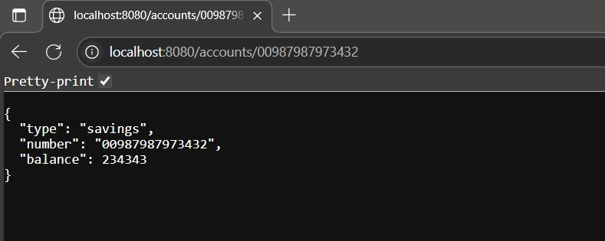

**C:\123456\microservices\loan**

**src\main\java\com\cognizant\loan\LoanApplication.java**

package com.cognizant.loan;

import org.springframework.boot.SpringApplication;

import org.springframework.boot.autoconfigure.SpringBootApplication;

@SpringBootApplication

public class LoanApplication {

public static void main(String[] args) {

SpringApplication.run(LoanApplication.class, args);

    }

}

**src\main\java\com\cognizant\loan\controller\LoanController.java**

package com.cognizant.loan.controller;

import org.springframework.web.bind.annotation.GetMapping;

import org.springframework.web.bind.annotation.PathVariable;

import org.springframework.web.bind.annotation.RestController;

import java.util.Map;

@RestController

public class LoanController {

@GetMapping("/loans/{number}")

public Map<String, Object> getLoan(@PathVariable String number) {

return Map.of(

"number", number,

"type", "car",

"loan", 400000,

"emi", 3258,

"tenure", 18

);

}

}

**src\main\resources\application.properties**

server.port=8081

**OUTPUT:**

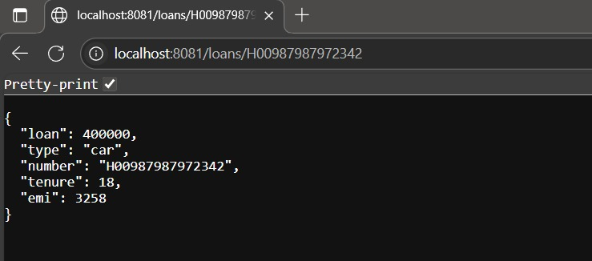

**Create Eureka Discovery Server and register microservices**

**File Structure:**

**microservices**

**├── discovery-server**

**│ ├── src**

**│ │ └── main**

**│ │ ├── java**

**│ │ │ └── com/example/discoveryserver**

**│ │ │ └── DiscoveryServerApplication.java**

**│ │ └── resources**

**│ │ └── application.yml**

**│ └── pom.xml**

**├── account-service**

**│ ├── src**

**│ │ └── main**

**│ │ ├── java**

**│ │ │ └── com/example/accountservice**

**│ │ │ ├── AccountServiceApplication.java**

**│ │ │ └── controller/AccountController.java**

**│ │ └── resources**

**│ │ └── application.yml**

**│ └── pom.xml**

**├── loan-service**

**│ ├── src**

**│ │ └── main**

**│ │ ├── java**

**│ │ │ └── com/example/loanservice**

**│ │ │ ├── LoanServiceApplication.java**

**│ │ │ └── controller/LoanController.java**

**│ │ └── resources**

**│ │ └── application.yml**

**│ └── pom.xml**

**CODE:**

**discovery-server (Eureka Server)**

**pom.xml**

<project>

<modelVersion>4.0.0</modelVersion>

<groupId>com.example</groupId>

<artifactId>discovery-server</artifactId>

<version>0.0.1-SNAPSHOT</version>

<packaging>jar</packaging>

<name>discovery-server</name>

<parent>

<groupId>org.springframework.boot</groupId>

<artifactId>spring-boot-starter-parent</artifactId>

<version>3.1.5</version>

</parent>

<dependencies>

<dependency>

<groupId>org.springframework.cloud</groupId>

<artifactId>spring-cloud-starter-netflix-eureka-server</artifactId>

</dependency>

<dependency>

<groupId>org.springframework.boot</groupId>

<artifactId>spring-boot-starter</artifactId>

</dependency>

</dependencies>

<dependencyManagement>

<dependencies>

<dependency>

<groupId>org.springframework.cloud</groupId>

<artifactId>spring-cloud-dependencies</artifactId>

<version>2022.0.4</version>

<type>pom</type>

<scope>import</scope>

</dependency>

</dependencies>

</dependencyManagement>

</project>

**src/main/resources/application.yml**

server:

server.port=8761

eureka.client.register-with-eureka=false

eureka.client.fetch-registry=false

logging.level.com.netflix.eureka=OFF

logging.level.com.netflix.discovery=OFF

**src/main/java/com/example/discoveryserver/DiscoveryServerApplication.java**

package com.example.discoveryserver;

import org.springframework.boot.SpringApplication;

import org.springframework.boot.autoconfigure.SpringBootApplication;

import org.springframework.cloud.netflix.eureka.server.EnableEurekaServer;

@SpringBootApplication

@EnableEurekaServer

public class DiscoveryServerApplication {

public static void main(String[] args) {

SpringApplication.run(DiscoveryServerApplication.class, args);

}

}

**OUTPUT(Eureka Server):**

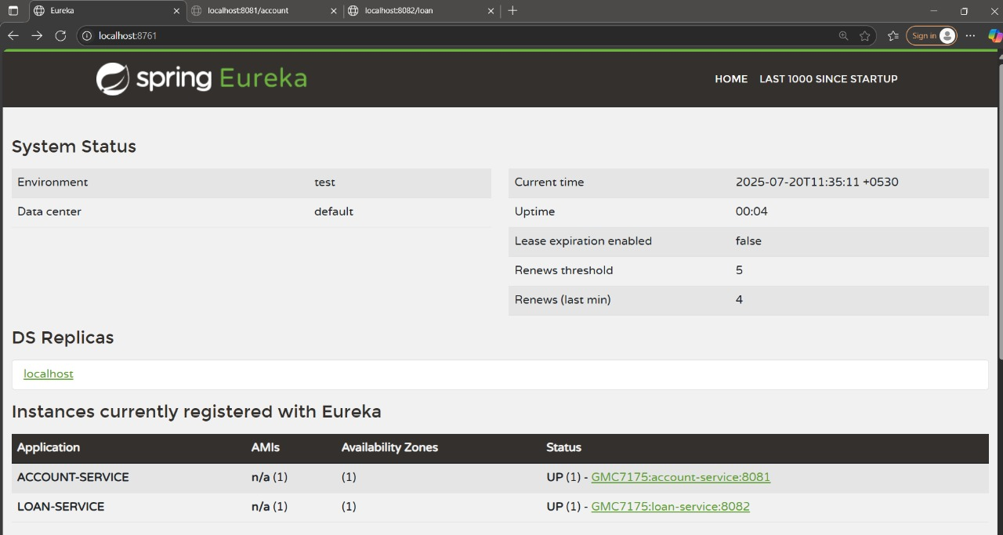

**account-service**

**pom.xml**

<project>

<modelVersion>4.0.0</modelVersion>

<groupId>com.example</groupId>

<artifactId>account-service</artifactId>

<version>0.0.1-SNAPSHOT</version>

<parent>

<groupId>org.springframework.boot</groupId>

<artifactId>spring-boot-starter-parent</artifactId>

<version>3.1.5</version>

</parent>

<dependencies>

<dependency>

<groupId>org.springframework.boot</groupId>

<artifactId>spring-boot-starter-web</artifactId>

</dependency>

<dependency>

<groupId>org.springframework.cloud</groupId>

<artifactId>spring-cloud-starter-netflix-eureka-client</artifactId>

</dependency>

</dependencies>

<dependencyManagement>

<dependencies>

<dependency>

<groupId>org.springframework.cloud</groupId>

<artifactId>spring-cloud-dependencies</artifactId>

<version>2022.0.4</version>

<type>pom</type>

<scope>import</scope>

</dependency>

</dependencies>

</dependencyManagement>

</project>

**src/main/resources/application.yml**

server:

port: 8081

spring:

application:

name: account-service

eureka:

client:

service-url:

defaultZone: <http://localhost:8761/eureka>

**src/main/java/com/example/accountservice/AccountServiceApplication.java**

package com.example.accountservice;

import org.springframework.boot.SpringApplication;

import org.springframework.boot.autoconfigure.SpringBootApplication;

@SpringBootApplication

public class AccountServiceApplication {

public static void main(String[] args) {

SpringApplication.run(AccountServiceApplication.class, args);

}

}

**src/main/java/com/example/accountservice/controller/AccountController.java**

package com.example.accountservice.controller;

import org.springframework.web.bind.annotation.GetMapping;

import org.springframework.web.bind.annotation.RestController;

@RestController

public class AccountController {

@GetMapping("/account")

public String getAccountDetails() {

return "Account Service Response";

}

}

**OUTPUT:**

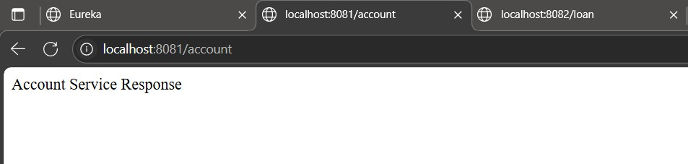

**loan-service**

**pom.xml**

<project>

<modelVersion>4.0.0</modelVersion>

<groupId>com.example</groupId>

<artifactId>loan-service</artifactId>

<version>0.0.1-SNAPSHOT</version>

<parent>

<groupId>org.springframework.boot</groupId>

<artifactId>spring-boot-starter-parent</artifactId>

<version>3.1.5</version>

</parent>

<dependencies>

<dependency>

<groupId>org.springframework.boot</groupId>

<artifactId>spring-boot-starter-web</artifactId>

</dependency>

<dependency>

<groupId>org.springframework.cloud</groupId>

<artifactId>spring-cloud-starter-netflix-eureka-client</artifactId>

</dependency>

</dependencies>

<dependencyManagement>

<dependencies>

<dependency>

<groupId>org.springframework.cloud</groupId>

<artifactId>spring-cloud-dependencies</artifactId>

<version>2022.0.4</version>

<type>pom</type>

<scope>import</scope>

</dependency>

</dependencies>

</dependencyManagement>

</project>

**src/main/resources/application.yml**

server:

port: 8082

spring:

application:

name: loan-service

eureka:

client:

service-url:

defaultZone: <http://localhost:8761/eureka>

**src/main/java/com/example/loanservice/LoanServiceApplication.java**

package com.example.loanservice;

import org.springframework.boot.SpringApplication;

import org.springframework.boot.autoconfigure.SpringBootApplication;

@SpringBootApplication

public class LoanServiceApplication {

public static void main(String[] args) {

SpringApplication.run(LoanServiceApplication.class, args);

}

}

**src/main/java/com/example/loanservice/controller/LoanController.java**

package com.example.loanservice.controller;

import org.springframework.web.bind.annotation.GetMapping;

import org.springframework.web.bind.annotation.RestController;

@RestController

public class LoanController {

@GetMapping("/loan")

public String getLoanDetails() {

return "Loan Service Response";

}

}

**OUTPUT:**

